Name: _____________________________ Date: _____________Total Marks: ___________________

Multithreading in Windows Forms

- On the File menu, point to New, and then click Project.
- In the New Project dialog box, choose Windows Application.
- Add a NumericUpDown control (_digits), a Button control (_calcButton), a TextBox control (_pi), and a ProgressBar control (_piProgress) to the form.
- In Solution Explorer, right-click your project and select Add→ Class. Name it NineDigitsofPi.cs. Study the Computation of the N'th Decimal Digit of Pi located in:
ftp://share.bcit.ca/out/comp/2691/Monday%20Evenings/Assignments/AssignmentFive and then make the required changes to the NineDigitsofPi.cs class.
- Calculate Digits of Pi: While most applications do not need to calculate digits of pi, many kinds of applications need to perform long-running operations, whether it is printing, making a Web service call, or calculating interest earnings on a certain billionaire in the Pacific Northwest. Users are generally content to wait for such things, often moving to something else in the meantime, so long as they can see that progress is being made. That is why even our application has a progress bar. The algorithm I'm using calculates pi nine digits at a time. As each new set of digits are available, our program shall keep the text updated and shall move the progress bar. For example, Figure 1 shows progress on the way to calculating 1000 digits of pi.
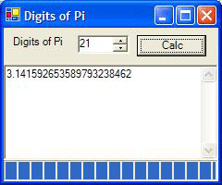
Figure 1. Digits of Pi application
- Canceling: Our program shall send messages back and forth between the worker and the UI threads. The UI thread doesn't have to wait for the worker thread to complete or even be notified on completion because the worker thread communicates it progress as it goes. Likewise, the worker thread doesn't have to wait for the UI thread to show progress so long as progress messages are sent at regular intervals to keep users happy. However, one thing doesn't make users happy—not having full control of any processing that their applications are performing. Even though the UI is responsive while pi is being calculated, the user would still like the option to cancel the calculation if they've decided they need 1,000,001 digits and they mistakenly asked for only 1,000,000.

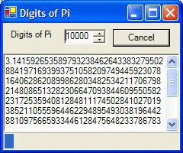
Figure 2. Letting the user cancel a long-running operation

Implementing cancel for a long running operation is a multi-step process.
First, a UI needs to be provided for the user. In this case, the Calc button is changed to a Cancel button after a calculation has begun. Another popular choice is a progress dialog, which typically includes current progress details, including a progress bar showing percentage of work complete, as well as a Cancel button.
- On the File menu, click Save All to save the project.

